St John’s Upper Holloway CE Primary School

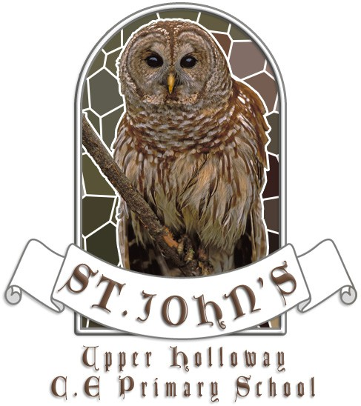

School Information Report

November 2022

St John’s C.E. Primary School
Jesus said: ‘Love each other as I have loved you’. John 15:12

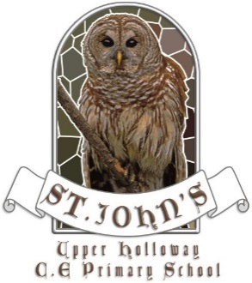

Our Vision
Jesus said: ‘Love each other as I have loved you’. John 15:12
As we are loved, so we shall love.
As we are taught, so we shall teach.
As we are nurtured, so we shall flourish.

Our Mission
- St John’s is a small, caring Church of England Primary School. It is committed to supporting our pupils to be happy, successful and fulfilled throughout their lives. We believe that everyone is unique and valued by God. We aspire to be a high achieving school that provides an outstanding education:
- promoting the highest standards of teaching and learning, with excellent leadership
- being inclusive, celebrating diversity and valuing all religions, faiths, cultures and backgrounds
- providing a rich and stimulating curriculum that will inspire and challenge
- being a happy, healthy and safe place
- providing excellent care, guidance and support with a strong partnership between school, parents and the community.

We seek to promote six Christian values of creativity, thankfulness, truthfulness, friendship, perseverance and courage, each linked by our core value of love. We believe these help to prepare our children for a successful and fulfilling life, so being:
- considerate and respectful with excellent manners
- confident, happy, independent and self-motivated
- co-operative and collaborative
- honest and trustworthy
- resilient, hardworking and determined
- highly principled with moral, spiritual, cultural and social awareness, including shared British Values.

St John’s, like all schools in Islington, is committed to meeting the needs
of all pupils including those with special educational needs and disabilities (SEN).
Our expectation is that children and young people with SEN will receive an
education that enables them to make progress so that they:

- achieve their best
- become confident individuals living fulfilling lives
- make a successful transition into adulthood, whether into employment, further or higher education or training

We will use our best endeavours to make sure that a pupil with SEN gets the
support they need – this means doing everything we can to meet the pupils special
educational needs.

About this Information Report
This report answers some of the most frequently asked questions about the school and special educational needs. The format and information in this report has been developed through:
- consultation with local parents and carers by Islington Council in April 2014
- ongoing feedback from parents and carers and school staff at St John’s

We will review and update this information report regularly to reflect changes and feedback. The date for the next annual review of this report is November 2023.
If you need any more information please see our SEN Policy (enclosed within our Inclusion policy) or contact Ms Rebecca Ross Goobey (SENco) on 0207 2722780.

Frequently Asked Questions

- What kinds of Special Educational Needs (SEN) does the school cater for?

St John’s is a mainstream primary school and welcomes children with SEN in one or more of the following areas:

- Communication and interaction
e.g. speech, language and communication needs (SLCN) Autism Spectrum Condition (ASC), Asperger’s Syndrome

- Cognition and learning
e.g. Specific learning difficulties (SpLD), moderate learning difficulties (MLD), severe learning difficulties (SLD), global developmental delay, dyslexia, dyscalculia and dyspraxia, profound and multiple learning difficulties (PMLD)
- Social, emotional and mental health difficulties (SEMH)
e.g. attention deficit hyperactive disorder (ADHD), depression, eating disorders, attachment disorder

- Sensory and/or physical needs
e.g. vision impairment (VI), hearing impairment (HI) or a multi-sensory impairment (MSI) or Cerebral Palsy (CP) epilepsy {Note – the building is not fully accessible to pupils with mobility difficulties. See section 6}

- Medical needs
Where pupils have medical needs and special educational needs, we will plan and deliver education provision in a co-ordinated way with their healthcare plan if they have one. We will also follow the statutory guidance on supporting pupils at school with medical conditions.

- What are the school's policies for the identification and assessment of pupils with special educational needs (SEN)?
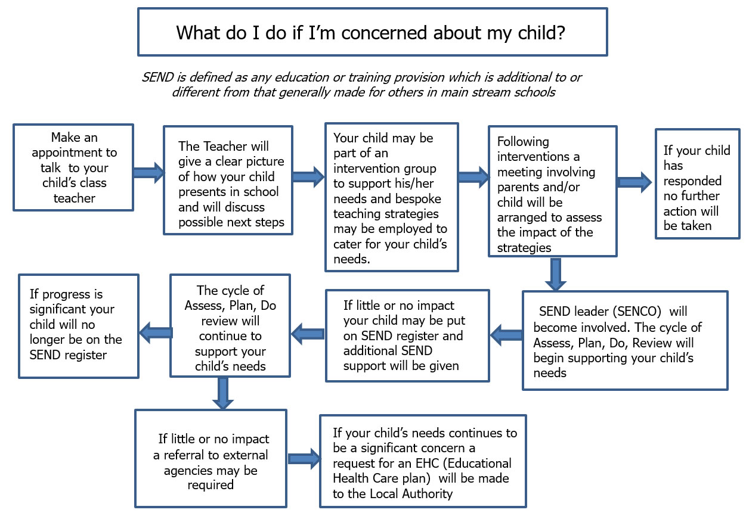
All of our teachers teach children with SEN. All of our staff recognise the importance of identifying SEN early and making effective provision quickly. The identification and assessment of SEN is built into the schools approach to monitoring the progress of all pupils.

We assess each pupil’s skills and levels of attainment when they first come to the school. This builds on the information from the child’s previous early years or school where appropriate, and provides us with information we need to monitor their progress. It also ensures that we discover any areas of difficulty early on. Where children already have their SEN diagnosed or identified we will work closely with the family and our partners to make sure we know as much as possible about the child before they start at the school.

Teachers are supported by the Senior Leadership Team to regularly assess pupils’ progress. This helps us to see any pupils whose progress:

- is significantly slower than that of their peers starting from the same baseline
- fails to match or better their previous rate of progress
- fails to close the attainment gap between them and their peers

Where assessments show that a child is not making adequate progress, our first response is to make sure there is high quality teaching in place. Making high quality teaching normally available to the whole class is likely to mean that fewer pupils will require additional support.

If their progress continues to be slower than expected the teacher will work with the family and the SENCO to carry out a clear analysis of the child’s needs and identify if they need additional support. There can be many reasons why a child doesn’t make the progress expected of them – perhaps there has been a significant change in family circumstances such as a new baby, a move of home, or the death of a relative. Or perhaps because they have a special educational need.

The school uses a range of different assessment tools and systems to help identify and assess pupils with SEN. The tools and assessments gradually draw upon more frequent reviews and more specialist expertise to understanding SEN and match interventions to the SEN of pupils. They are summarised in the diagram below:

When considering if a child needs SEN support the school takes into account:
- the pupil’s previous progress and attainment
- the teacher’s assessment and experience of the pupil
- the pupil’s development in comparison to their peers and national data
- the views and experience of parents
- the pupil’s own views
- advice from external support services, where appropriate

Further information is set out in our SEN Policy (enclosed within our Inclusion policy).

- What are the school’s policies for making provision for pupils with special educational needs (SEN), whether or not pupils have Education Health and Care Plans?

Most of our pupils with SEN have their needs met as part of high quality teaching. This may include teachers adapting what they do and having different approaches to meet different learning styles, personalised learning arrangements for different pupils and a range of interventions normally provided by the school.

If a pupil is identified (through the assessment process above) as having special educational needs their teacher and SENCO will consider everything we know about the pupil to determine the support that they need and whether it can be provided by adapting the school’s core offer or whether something different or additional is required.

Where provision for SEN is needed, we work with pupils and their families to plan what to do. This usually includes writing a plan of action using one of the SEN planning tools we have available to use. The tools we use are summarised below.

SEN Support

Provision Mapping: A document that is used to capture targeted and specialist interventions that will be ‘additional to’ and ‘different from’ the usual differentiated curriculum. An example of this can be found in the school’s SEN policy.

Pupil Passport: A document that contains a 1 page profile and an action plan listing the goals and provision to meet the SEN. An example of this can be found in the school’s SEN policy.

SEND Support Plan: A document containing a 1 page profile and a detailed action plan listing the goals and provision to meet the SEN. This is the same action plan that can be used as part of the eCAF and an even more detailed one can be found as Appendix A of the EHCP. An example of this can be found in the school’s SEN policy.

Education Health and Care Plan (EHCP) : Where the school has done everything it can to identify, assess and meet the SEN of the child and they are still not making the expected progress, the school or parents may consider requesting an Education, Health and Care assessment. The process for requesting an EHCP assessment in Islington can be found on the Council’s Local Offer website. www.islington.gov.uk/localoffer

Education Health and Care Plans are issued by the Local Authority where necessary and are used by the school to plan SEN provision for children with severe and complex needs. The EHCP includes:
- a detailed profile of the child, their strengths and aspirations for the future
- any education, health and care needs they have
- the goals or outcomes for the pupil agreed by the family and professionals for the next phase of their education
- any education, health and social care provision in place to meet their needs

The EHCP includes a detailed annual support plan/action plan. This plan sets out the goals for the pupil for the next year, and the activities that everyone supporting the child will put in place to support them.

The following table shows the number of pupils with SEN in the school in October 2020 and the type of tools we use to plan SEN provision:

SEN Planning Tool | Number of pupils
Provision Mapping | Constantly changing
Pupil Passport | 16
SEND Support Plan | 20
Education Health and Care Plans (EHCP) | 7

- How does the school evaluate the effectiveness of its provision for SEN?

The quality of teaching is the most important factor in ensuring all pupils make progress. We regularly review the quality of teaching in the school and ensure that teachers are able to identify how individual children learn best and what support they need.

We test the effectiveness of our SEN provision by checking pupil progress and to see if the agreed goals and outcomes for a pupil are being met. Where professionals from health or social services are involved with the child we will ask for their help to inform and review progress, to make sure that all those supporting the family are working together effectively.

The teachers work with the SENCO, the parents and the child to make sure any SEN support is adapted or replaced by another approach if it is not being effective.

The SENCO and the head teacher report regularly to Governors on the quality of SEN provision and the progress towards outcomes being made by pupils with SEN. Governors also consider the attainment data for pupils with SEN and compare it with the progress of other pupils and the progress of pupils in similar schools. This helps to ensure that the approaches used to meeting SEN are based on the best possible evidence and are having the required impact on progress.

- What are the school’s arrangements for assessing and reviewing the progress of pupils with SEN?

Every pupil in the school has their progress reviewed regularly and this information will be shared with both parents and pupils. We provide an annual report to parents on their child’s progress, at the end of the school year.

Where a pupil is receiving SEN support, we provide feedback to parents more regularly. We give verbal feedback to parents as often as is possible. We also contact parents by phone or email where we have specific feedback or need to discuss specific achievements, concerns or observations. Parents of those children with pupil passports or EHCP will also meet to review and discuss targets. Some pupils with SEN may have more frequent reviews if they are required.

Review meetings are usually led by the class teacher, as they have a good knowledge and understanding of the pupil’s needs and attainment, supported where necessary by the SENCO. If a pupil has TA allocation, then the TA may also be present at the meeting. Reviews normally last between 30 minutes and 1 hour, although this can vary if the child’s needs have changed or the review involves a range of different professionals. We always aim to allow sufficient time to plan effectively.

Reviews can involve the pupil, the family and other professionals where this is appropriate. They are used to:
- discuss what is working well and not working well
- find out if the SEN provision has been delivered as planned
- review the pupil’s progress towards their goals and longer term outcomes
- discuss and agree clear outcomes for the future
- discuss and agree the support needed
- share advice and information on the things that parents can do at home to reinforce or contribute to their child’s progress
- identify the actions needed to meet the agreed outcomes, the responsibilities of the parent, the pupil, the school, the local authority and other partners.

A record of the outcomes, action and support agreed through the discussion is then shared with all the appropriate school staff and the pupil’s parents. The annual review process used by Islington is now online.

When the school has an Ofsted inspection the Inspectors take a particular interest in the progress of pupils with SEN. The school’s most recent OFSTED inspection can be found on the school website.

- What is the school’s approach to teaching pupils with SEN?

All pupils, including those with SEN, have access to a broad and balanced curriculum. Teachers plan lessons carefully and think about the wide range of different needs in their class and use the information from assessments and progress reviews to set targets which are deliberately ambitious to encourage pupils to aim high. Teachers plan their lessons with the SEN of pupils in mind, which means that most pupils with SEN and disabilities will be able to study the full national curriculum along with their peers

Teaching staff always aim to match the work given to pupils with their ability to do it. School staff such as Teaching Assistants, and other more specialist staff, may be directed to work with pupils, in pairs or small groups and sometimes individually.

The type of SEN support provided is based on reliable evidence of what works. We are careful to avoid the over reliance of individual support for pupils as evidence shows that in many cases this prevents them becoming independent learners.

The SENCO, supported by the Senior Leadership Team ensures that staff have sufficient skills and knowledge to deliver the interventions that pupils need.

- How does the school adapt the curriculum and learning environment for pupils with SEN?

We are committed to meeting the needs of all pupils including those with SEN. We have a duty not to directly or indirectly discriminate against, harass or victimise disabled children and young people. We make all reasonable adaptations to the curriculum and the learning environment to make sure that pupils with SEN are not at a substantial disadvantage compared with their peers.

We work closely with families and partners to work out what disabled children and young people might need before they start with us, and what adjustments we might need to be make. We discuss with families what we can do to adapt the curriculum and/or the building as necessary, and in order to getting additional resources and support.

Teachers will be supported by the SENCO (and/or outside professionals where appropriate) to assess, plan and differentiate the curriculum or make adaptations to meet the needs of pupils with SEN. For example we might need to:

- provide visual resources to support learning
- install a wheelchair ramp
- rearrange the layout of the classroom
- install sound loops
- create a quiet area in the school
- buy specialist ICT software
- identify appropriate ancillary aids and assistive technology, including Augmentative and Alternative Communication (AAC) and support the families application for funding to purchase the equipment.

In considering what adaptations we need to make, the SENCO will work with the head teacher and school governors to ensure that the school meets its responsibilities under the Equality Act (2010) with regard to reasonable adjustments and access arrangements. A link to the Equality Act 2010 can be found here: http://www.legislation.gov.uk/ukpga/2010/15/contents

Further information explaining how we meet the duty can be found on the school website.

e) What additional support for learning is available to pupils with SEN?

The school organises the additional support for learning into 3 different levels (also called waves).

Wave 1 (Universal): describes quality inclusive teaching which takes into account the learning needs of all the children in the classroom. This includes providing differentiated work and creating an inclusive learning environment.

Wave 2 (Targeted): describes specific, additional and time-limited interventions provided for some children who need help to accelerate their progress to enable them to work at or above age-related expectations. Wave 2 interventions are often targeted at a group of pupils with similar needs.

Wave 3 (Specialist): describes targeted provision for a minority of children where it is necessary to provide highly tailored intervention to accelerate progress or enable children to achieve their potential. This may include specialist interventions.

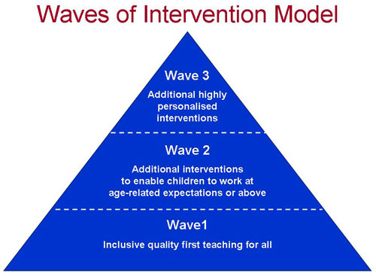
The provision available at each level (or wave) is summarised in our school provision map.

We provide additional support for pupils with SEND to be able to access exams, when needed.

We are able to support the administration of medication if it is recommended by health professionals.

f) What extra-curricular activities are available for pupils with SEN?

The school has a range of extra circular activities including:
- A breakfast club each morning between 8am – 9am
- Lunchtime activities
- After school clubs including homework club, sports and art clubs.

The current list of activities for this term can be found by speaking to the school office on 020 7272 2780.

We make our best efforts to ensure that all pupils with SEN can engage in these activities of the school alongside pupils who do not have SEN. Where it is agreed that taking part in these activities will contribute significantly to meeting the agreed outcomes for a pupil with SEN the school will normally be able to pay for any training, resources or equipment that may be needed.

The school also provides opportunities for pupils to go on school trips and we organise an annual residential trip for year 6. We will involve parents of pupils with SEN in the planning of school trips and residential to assess the benefits and risks and identify how the needs of individual pupils can be best met.

g) What support is available for improving the emotional and social development of pupils with SEN?

The culture and structures within the school aim to encourage the emotional and social development for all pupils, including those with SEN.

We work hard to create a culture within the school that values all pupils, allows them to feel a sense of belonging and makes it possible to talk about problems in a non-stigmatising way. We have clear policies on behaviour and bullying that set out the responsibilities of everyone in the school. We have clear systems and processes so that staff can identify and respond to mental health difficulties.

For children with more complex problems, additional in-school interventions may include:

- advice and support to the pupil’s teacher - to help them manage the pupil’s behaviour within the classroom, taking into account the needs of the whole class
- small group sessions - to promote positive behaviour, social development and self-esteem
- playground buddies – to support pupils in joining in playtime activities, forming friendships and helping them to deal with situations positively
- individual action plans or behaviour support plans - to support pupils during their school day
- additional support for the pupil – to help them cope better within the classroom
- therapeutic work with the pupil, delivered by specialists (within or beyond the school), which might take the form of cognitive behavioural therapy, behaviour modification or counselling approaches, family support and/or therapy by health professionals – to help the child and their family better understand and manage behaviour.

For further information please see our behaviour management policy.
- Who is the SEN Co-Ordinator and how do I contact them?

Our Special Education Needs Coordinator (SENCO) is also the school’s Deputy Head. She is a qualified teacher working at the school who has responsibility for SEN. She works closely with the Head teacher and Governing Body as well as all teachers. If you have concerns about your child you should speak to your child’s teacher before you speak to the SENCO.

The SENCO is responsible for:

- overseeing the day-to-day operation of the school's SEN policy
- coordinating provision for children with special educational needs
- liaising with and advising fellow teachers
- overcoming barriers to learning and sustaining effective teaching
- managing teaching assistants
- overseeing the records of all children with SEN and Disability
- liaising with parents of children with SEN
- planning successful movement (transition) to a new class group or school
- providing specialist advice and facilitating training to ensure that all staff are skilled and confident about meeting a range of needs
- liaising with external agencies including the LA’s support and educational
psychology services, health and social services, and voluntary bodies

Ms Rebecca Ross Goobey - Special Educational Needs Coordinator (SENCO for short)
Phone: 0207 2722780

The SENCO is a full time member of staff.

You can request a meeting with the SENCO by phone or in person at the school office. The SENCO is also available in the school playground or at the gate most mornings between 8.45-9.05.

- What expertise and training do the school staff have in relation to SEN and how will specialist expertise be secured?

The school supports its staff to access a wide range of information on appropriate interventions for pupils with different types of need, and to access associated training to ensure they have the necessary knowledge and expertise.

The responsibility for ensuring staff have the appropriate training and expertise to meet the needs of pupils with SEN training is shared between the Head teacher, SENCO and the Governing body. We closely monitor the training and development needs of our staff through annual appraisal.

The following tables show the training and expertise of the school staff.
General SEN training for all staff

Details of training / expertise | % of school staff trained
Introduction to SEND
First Aid | 40%
How to support pupils on the autistic spectrum | 28%
How to support pupils with emotional needs | 100%
Dyslexia – strategies to support pupils in school | Support for staff from dyslexia tutor
*further training planned for 2021-22

Specific SEN training and expertise

Details of training / expertise | School staff
Accredited SENCO (National Award) | 1
Accredited Teacher for Specific Learning Difficulties (Dyslexia) | 1 (part time)
Epi pen and allergy training | All

Specialist SEN Training (for specific children)

Details of training/ expertise | School staff trained
Manual handling
Training by the Occupational Therapy and Physio teams | 3
The Bridge | All
ADHD
Makaton | 2
Samuel Rhodes School (supporting pupils with Down Syndrome) | 2

Our staff also access training and materials provided through outreach services offered to mainstream schools by each of Islington’s special schools. SEN training and expertise will be sought when the needs of individual children require it, for example when there is a need to prepare for a child coming to the school. This can include:

- Reading about the conditions
- Visits to other schools to see good practice
- Home visits
- Training by the Complex Care Nursing Team

We have the following specialist services who work with our school:
- Speech and Language
- CAMHS
- The Bridge
- Hampstead Dyslexia Clinic
- School nursing team
- Educational Psychologist
- Occupational Therapist
- Physiotherapist
- Whittington hospital outreach
- Richard Cloudesley outreach
- Samuel Rhodes outreach
- New River College (PRU) outreach

- What equipment and facilities are available to support pupils with SEN?

St John’s has two main buildings (EY/KS1 and KS2), both of which are located on flat surfaces. It has two main playgrounds, one at surface level (lower playground) and one located via a set of steps (upper playground). There is a separate purpose-built Early Years playground at surface level. Classrooms have ramp access, as does the main entrance to the school foyer. The school has two purpose-built disabled toilets. There is a disabled parking bay within 10 metres of the school gate.

The school will consider purchasing equipment if there is an agreed identified need. We will normally consider this at the pupil’s termly or annual review.

In the past we have worked with partners to purchase specialist equipment tailored for individual pupils including:

- Personal ipad
- Personal kindle
- Move and sit cushion
- Specialist hand writing equipment
- Oral sequencing storyboards

- What are the arrangements for consulting and involving parents of children with SEN in their child’s education?

All parents are encouraged to contribute to their child’s education through:

- discussions with the class teacher
- setting and reviewing targets
- parents evenings
- during discussions with Mr Turpin (SENCO) or other professionals
- commenting and contributing to assessment, planning and reviews

If your child has a SEN statement or an Education, Health and Care plan we will discuss their progress with you every term and have a formal review with you and your child at least annually. Further information about reviews can be found in question 3b above.

Specific support to help you support your child at home will include:

- Meetings with teachers and SEN staff to discuss progress and support including ideas for home.
- Parents as Educators programmes e.g. maths workshops, Early years workshops on maths, Early writing, phonics and reading

If we think your child needs significant amounts of extra support we will always discuss this with you and, where appropriate, a meeting with the parents and the people supporting your child can be arranged.

Where required we will arrange interpreters to enable parents to fully participate in formal meetings.

We have parents, Parent Governors and SEND Governors who are happy to talk with prospective parents to share their experience and answer any questions you may have; if you would like to talk with one of them please contact the SENCo on 0207 272 2780.

- What are the arrangements for consulting and involving pupils with SEN in their education?

Engaging all pupils as active participants in their own education and in making a positive contribution to their school and local community is a priority for the school. All children are consulted about their learning and how they feel about a range of topics annually before the spring term parents’ meeting. A summary of these findings are discussed with parents at the parents meetings.

Where pupils have SEN, we will take extra care to involve them and make sure their voice is heard. Their involvement will be tailored to each child and take into account their preferred methods of communication. This may include:

- providing them with relevant information in accessible formats

- using clear ordinary language and images rather than professional jargon

- giving them time to prepare for discussions and meetings
- dedicating time in discussions and meetings to hear their views
- involving the pupil in all or part of the discussion itself, or gathering their views as part of the preparation

- supporting their access to an adult who can help them express their views where necessary (this could be a family member or a professional)
- ensuring staff are skilled in working with children, parents and young people to help them make informed decisions and have access to training so they can do this effectively

We ensure that pupils with SEN are included and represented in the groups and activities that we have set up to listen to the views of pupils and involve them in decision-making. These groups and activities include:
- The School Council
- Annual pupil survey

The views of the individual child and young person sit at the heart of the SEN assessment and planning process. We will make sure that assessments include the wishes and feelings of the child, their aspirations, the outcomes they wish to seek and the support they need to achieve them. Whenever possible we include pupils with SEN in planning how best to support them, and in reviewing their progress. This may include the use of questionnaires, story boards or symbols.

All pupils with SEN will have specific goals and outcomes and they will be part of the discussion to agree and review these. Where a personal budget is being used for those with an EHCP, the school will support the child’s involvement in decisions about their support.

- What are the arrangements for parents raising concerns and making a complaint about the SEN provision at the school?

We are committed to providing excellent services to all our children and their parents and we believe the best way to do this is to listen to your views. We encourage parents to contact us about their concerns and not to wait for the next formal opportunity to meet. So if you have something to tell us, whether good or bad, please contact the class teacher or SENCO.

If you have a complaint about SEN provision, please tell us promptly by contacting the following people in this order;
- the class teacher
- the SENCo (details below)
- The head teacher – using the main school number
- The SEN governor (a letter can be submitted through school office)

The SEN governor will then refer to the complaints procedure to try and address the issue.

Further information about our complaints procedure can be found in the school’s complaints policy (on the website or outside the school office).

We realise that parents can sometimes find schools a bit scary and may need someone to help them approach us if things aren’t going well. If you need support to raise a concern or make a complaint this you may want to contact Islington SEND Community Support Service.
The Service provides free, legally based, impartial, confidential and accessible information, advice and support on all matters relating to special educational needs and disabilities (SEND). You can contact them on 020 3031 6651 and 020 3031 6652.
www.family-action.org.uk/what-we-do/children-families/sendias/islingtonsend/
As a matter of last resort parents can also make a formal complaint to Ofsted: guidance for parents can be found here http://www.ofsted.gov.uk/schools/for-parents-and-carers/how-complain, or by phone on 0300 123 4666.
Further information on local support for families of pupils with SEN can be found in the Local Offer. See question 13 below.

- How does the school involve others in meeting the needs of pupils with SEN and in supporting the families of such pupils?

Where a pupil continues to make less than expected progress, despite evidence-based support and interventions that are matched to the pupil’s area of need, we seek advice and support from specialists from outside agencies such as:
- educational psychologists
- Child and Adolescent Mental Health Services (CAMHS)
- specialist teachers
- therapists (including speech and language therapists, occupational therapists and physiotherapists)
- Social workers

We always involve parents in any decision to involve specialists.

The SENCO is the person who usually coordinates the contact and works with these outside agencies. We mainly use other agencies outside of the school to:

- help us train staff e.g. epilepsy and diabetes ,tube feeding,
- get more specialised advice e.g. advice on hearing impairment
- carry out assessments e.g. a social care assessment
- ask for a service to be delivered e.g. physiotherapy
- setting programmes for implementation at home and in school
- review progress and plan provision e.g at annual reviews

The main agencies used by the school are shown earlier in this document.

Parents will always be invited in to meet any outside agencies, if those agencies are to be involved with their children.

- What local support is there for the parents of pupils with SEN?

Information about local support is located here: www.islington.gov.uk/localoffer

The Family Information Service - 020 7527 5959
Gives free impartial information, advice and guidance about services for children, young people and families.
email fis@islington.gov.uk
Website: www.islington.gov.uk/fis

Islington SENDIAS, provided by Family Action:
Offers a range of services to assist the parents/carers of children with SEND. These include: help with resolving disagreements, information and advice, direct support, help with personal budgets and form filling, and access to social groups and other activities and local networks.
Website: www.family-action.org.uk/what-we-do/children-families/sendias/islingtonsend/

- What are the school’s arrangements for supporting pupils with SEN when they join the school, and supporting them to move to secondary school / further education, training or employment/ adulthood and independent living?

All children and young people with SEND and their families may be particularly anxious about changing classes or “moving on” from school to school. We work with families and our partner organisations to make sure changes are planned and well managed.

Transition guide table:

 | Additional arrangements for children with SEN (examples)
In to nursery / Reception | - Swift transfer of records  - Home visit  - Work with Islington’s Early Years Inclusion Team  - Transition meeting with the previous setting  - Transition plan drawn up with main carer and your child (could include managed visits, pictures or transition book or video, social stories about ‘moving on’)
When moving to another school | - We will contact the School SENCO and share information about the special arrangements and support that has been made to help your child achieve their learning goals.  - Swift transfer of records  - Transition meeting with the new setting  - Transition plan (as above)
When moving groups/ forms/ classes in school | - Transition meetings are held within school with the new class teacher and home/school communication books passed up.  - Work with child to prepare for the next class through: Transition books, transition programme, visual supports and visits to the next setting. This will be shared with parents and transition books that can be taken home over the holidays.
Primary to secondary transition | - Swift transfer of records  - Year 5 annual reviews planning meeting  - During Year 6 the SENCO will attend the Secondary Transfer Conference to discuss the specific needs of your child, and the nature and level of support which has had the most impact, with the secondary school they will be transferring to  - Additional multi-agency meetings will be arranged to create a more detailed “transition” plan which may include more visits to the new school and/or additional visits from the new school for the children where these changes are more complex

- Where can I find more information about SEND services in Islington and the local area (the Local Offer)?

All Local authorities must publish a Local Offer, setting out in one place information about provision they expect to be available across education, health and social care for children and young people in their area who have SEN or are disabled.

The Local Offer has two key purposes:

- to provide clear, comprehensive and accessible information about the available provision and how to access it
- to make provision more responsive to local needs and aspirations by directly involving disabled children and those with SEN and their parents, and disabled young people and those with SEN, and service providers in its development and review

The school cooperates with the Local Authorities in the local area to:

- make families aware of the kind of support available to them and where to find the Local Offer
- help people access the Local Offer information, especially where there are barriers to them accessing it. This can include helping them to access the internet, printing off pages, explaining and interpreting technical language.
- consult children and young people and their families directly in preparing and reviewing the Local Offer
- keeping the Local Offer information up to date and identifying gaps in provision
To find out more about the range of services on offer locally go to:

Islington Local Offer: www.islington.gov.uk/localoffer

Appendix 1 External organisations

Name | Areas of expertise/ training
Early Years Inclusion Team | Social, communication, physical
Richard Cloudesley Outreach Service | Pupils with physical difficulties
The Bridge School Outreach Service | Sarah Tyce  (Autism and Profound and Multiple Learning Difficulties)
Samuel Rhodes School Outreach | Pupils with Medium Learning Difficulties
Educational Psychology Service | Problems around accessing the curriculum
CAST (Child & Adolescent Support Team)

CAMHS (Child & Adolescent Mental Health Service) | Clinical Psychologist
AAP (Attendance Advisory Practitioner previously known as Educational Welfare Officers)
Children’s Therapy Team (Speech & Language/Occupational Therapy)

Learning Support Service

Behaviour Support Service | PRU Outreach
Child Protection Advisors
PASS (Physical & Sensory Service) to support pupils with hearing/visual Impairment

Inclusion Team | Islington SEN
Social Services | Islington Children’s Contact Team

Approved by staff: Nick Turpin (head) on 07.12.22 (date)

Approved by governors ____________________ (chair of C&S committee) on

______

