22nd June 2020 - Reception Class This week our story is: The cow that laid an egg
PLEASE REMEMBER TO USE YOUR PHONICS WHEN YOU WRITE.
Writing  Remember to use capital letters at the beginning of your sentence, finger spaces and full stops! |  | Maths | Reading/phonics | Physical | Science/DT
Monday | Last week the children in school talked about the something they had seen on the news. Somebody had hatched duck eggs that they had bought from Waitrose. We have bought duck eggs from Waitrose and out them in an incubator. Watch the story at: https://www.youtube.com/watch?v=vOYQJOGnIUM | Please log on to Doodle maths.  The children should play for 30 minutes every day.  We are back on top of the leader board for doodlemaths – we beat Year 2 by 2% last week so make sure that you stay in the GREEN zone!  If you have any issues logging on then please email me at b.dickey@st-johnsholloway.islington.sch.uk  Our duck eggs are going to take 28 days to hatch – create a number line going from 28 to 0. | Google Mr Thorne does phonics - and go through the phase 2 and phase 3 sounds.  Read a reading book every day- Encourage the children to think about the characters and the plot.  If you haven’t already uploaded a video of you reading please do it today and post it on seesaw. This will help me to judge your book level and see if you need to go up a level.  If you have any issues logging onto Seesaw please let me know. All homework is going to be sent through Seesaw from the beginning of June. | Choose from one of the following to complete everyday:  Cosmic kids yoga at the farm  https://www.youtube.com/watch?v=YKmRB2Z3g2s  PE with Joe Wicks  https://www.thebodycoach.com/blog/pe-with-joe-1254.html  Choose a song from Go Noodle  https://www.gonoodle.com/ | I wonder if you think our eggs will hatch?  Look on the internet and see if there is anything we can do to help them. Find out some facts about hatching eggs.  Create your own 3D farm. Send a picture of your farm to me on Seesaw.
Tuesday | Do you think the chickens were right to trick the cows? Justify your answer. Why do you think that? 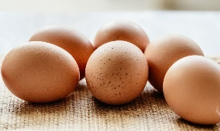
Wednesday | The cows were reading newspapers which had stories about Marjorie. Create your own newspaper - write news stories and draw pictures.
Thursday | If you were the chicken how would you have cheered up Marjorie?  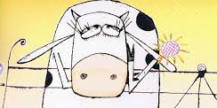
Friday | What was your favourite part of the story? Was there a part of the story that you didn’t like? Can you think of a different ending?  