15th June 2020 - Reception Class
This week our story is: Pirates love underpants.
PLEASE REMEMBER TO USE YOUR PHONICS WHEN YOU WRITE.
Writing  Remember to use capital letters at the beginning of your sentence, finger spaces and full stops! |  | Maths | Reading/phonics | Physical | Science/DT
Monday | Listen to the story pirates love underpants. https://www.youtube.com/watch?v=Vd8_Y1bEzA8 | Please log on to Doodle maths.  The children should play for 30 minutes every day.  We are back on top of the leader board for doodlemaths – having beaten Year 2! However, they are close on our heels so everybody needs to make sure that they are logging on and stay in the green zone!  If you have any issues logging on then please email me at b.dickey@st-johnsholloway.islington.sch.uk | Google Mr Thorne does phonics - and go through the phase 2 and phase 3 sounds.  Read a reading book every day- Encourage the children to think about the characters and the plot.  If you haven’t already uploaded a video of you reading please do it today and post it on seesaw. This will help me to judge your book level and see if you need to go up a level.  If you have any issues logging onto Seesaw please let me know. All homework is going to be sent through Seesaw from the beginning of June. | Choose from one of the following to complete everyday:  Cosmic kids yoga  https://www.youtube.com/user/CosmicKidsYoga  PE with Joe Wicks  https://www.thebodycoach.com/blog/pe-with-joe-1254.html  Choose a song from Go Noodle  https://www.gonoodle.com/ | Make your own pirate ship out of junk boxes.  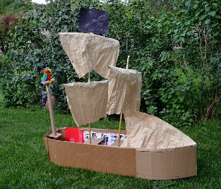  Does your boat float? Is there anything you could do to make it float?  Make a pirate hat.  https://www.twinkl.co.uk/resource/t-t-2548201-how-to-make-a-pirate-hat-instruction-activity-sheet
Tuesday | Pirates love underpants is a rhyming story. We are going to make our own rhyming book together.  Write down a list of words that rhyme with: pirate, parrot, ship, underpants, run, captain, children, boat, gold, treasure chest, sea, waves, island, night, yo ho ho.  I will send you the finished rhyming book as soon as it is finished.
Wednesday | Make your own pirate book! You can choose what type of ending your book has – happy, sad, funny or silly.
Thursday | Read the message that the pirates left on the underpants in the garden. Answer the questions.
Friday | We are going to invite the pirates to a picnic. What type of food do you think we should have? Write an invitation for the pirate.  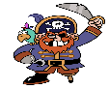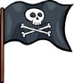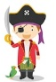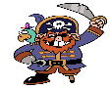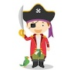  This Photo by Unknown Author is licensed under CC BY-SA  This Photo by Unknown Author is licensed under CC BY-SA

