**Home Learning for Nursery**

H everybody, I hope that you are well and are getting through this very strange time. Here are a few ideas to keep the children engaged and learning over the Easter holidays:

Islington Library Service has set up a yputube channel:

<https://www.youtube.com/channel/UCd-Y7IRIUtf2MOo9Og9_nGQ?app=desktop>

Oliver Jeffers has set up an online reading session which can be found at:

<https://www.oliverjeffers.com/abookaday/>

<https://abcdoes.com/abc-does-a-blog/2020/03/14/at-least-50-fantastic-ideas-to-try-at-home/>; A bank of ideas drawn together by Alistair Bryce Clegg with practical activities that can easily be done at home and is updated every week.

<https://theimaginationtree.com/stay-at-home-survival-guide/>. The imagination tree website has been developed by an EY teacher and parent of 4 young children with planning, play and learning ideas for self-isolation. It has a selection of lovely ideas that stress the importance of keeping things as playful, fun and as active as possible

<https://hungrylittleminds.campaign.gov.uk/>. Hungry Little Minds, the DfE webite, has activities broken down by age with a ‘chat, play, read’ emphasis. There are accompanying video clips and links to other sites and apps.

<https://www.bbc.co.uk/tiny-happy-people> has communication focussed ideas, broken down by age with the tagline ‘talk, bond and have fun’.

The Bright Start Bright Ideas newsletter goes out every two weeks, you can subscribe to it here; **<http://bit.ly/BSBIsubscribe>;**

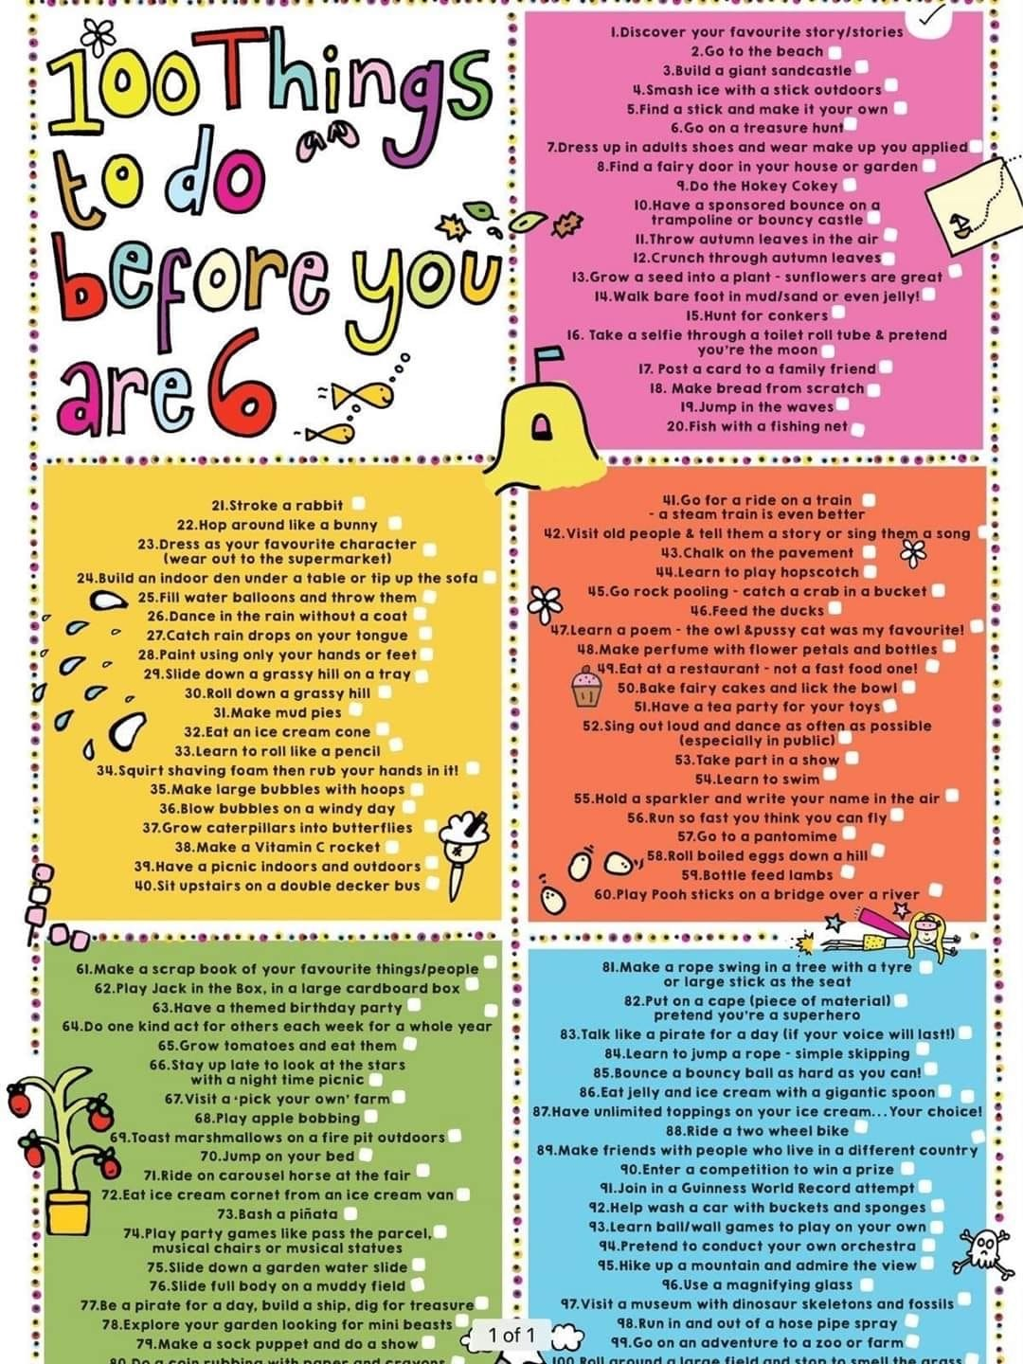

I know that lots of these require you to go outside - but some are now available online and it is good to make a wish list of things to do when everything gets back to normal!

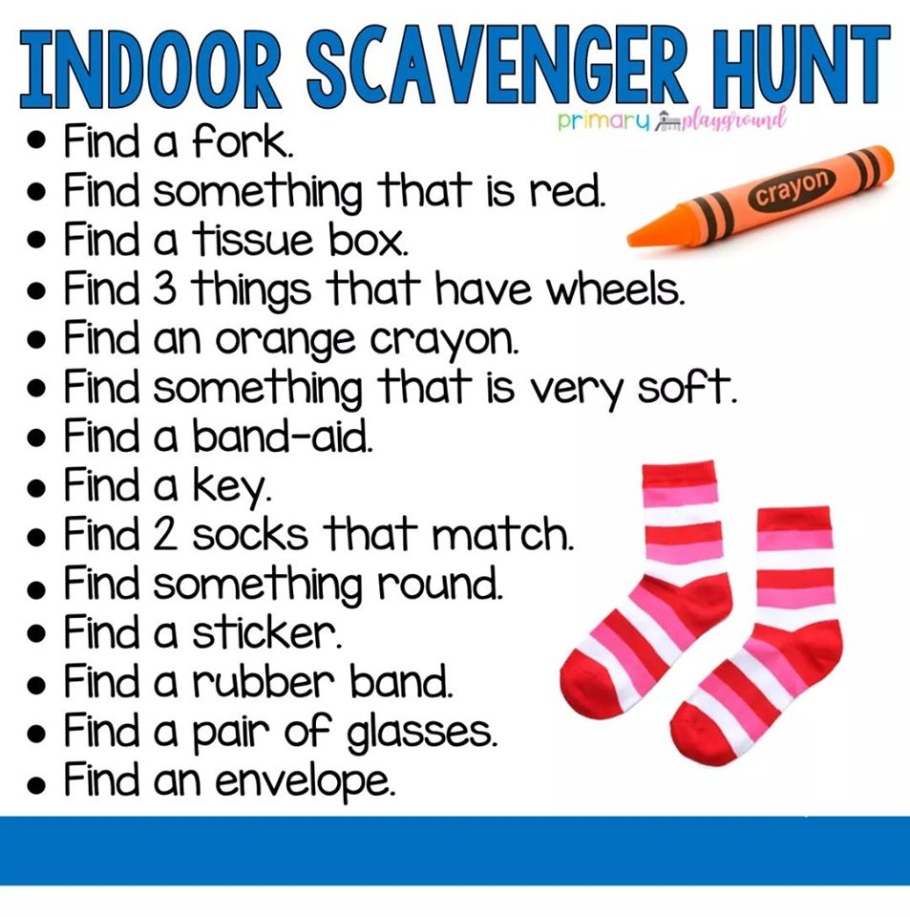

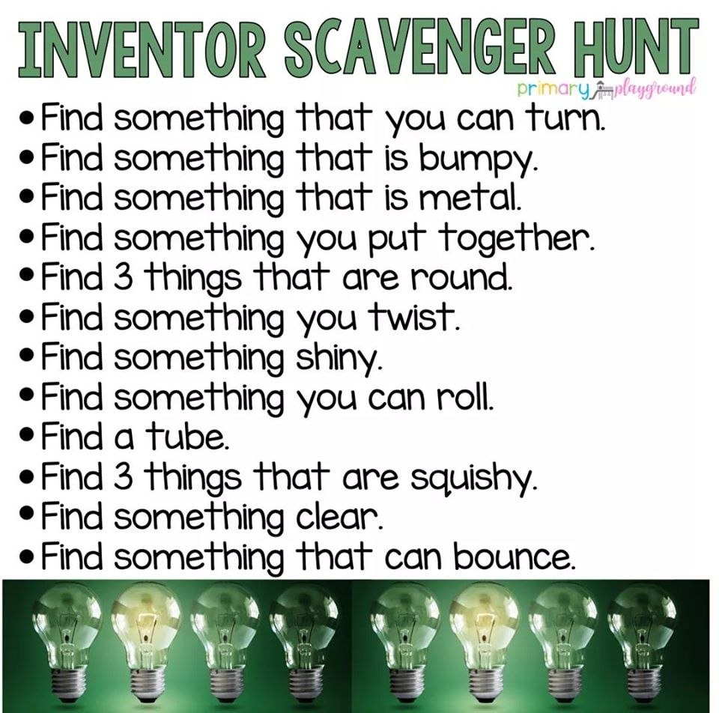

Please make sure that you log on to Busy things. This has great activities for early literacy and phonics and brilliant maths games. If you have problems logging on then please let me know asap.

Activities to encourage pencil control:

* Play with Duplo/Lego as much as you can!
* Try threading – beads are great but making a pasta necklace is better!
* Lots and lots and lots of play dough!

**Here is a really easy play dough recipe:**

2 cups of plain flour

2 cups of salt

2 cups of water

1 tablespoon of cream of tartar (optional – it just keeps it fresh longer!)

Any food colouring or paint to colour it – use a small amount.

Mix everything together in a microwable bowl and then cook in the microwave – start with 2 minutes, then 1 minute after that – if you overcook it and it turns into breadcrumbs then wrap it in a damp tea towel.

Pack in an airtight container and store in the fridge.

* Painting – either with paint on paper or water on the floor if you are lucky enough to have a garden or balcony.
* And finally – any kind of mark making – make sure that they have lots of opportunities to draw and write!
* I am sending home a pre writing pattern booklet. Support the children to complete a page per day.
* I am sending home a laminated writing pattern and a wipe off pen – you can reuse this over and over again.

It would be great to see some of the things they have been doing at home. You can send pictures or short videos to [b.dickey@st-johnsholloway.islington.sch.uk](mailto:b.dickey@st-johnsholloway.islington.sch.uk) or if you are struggling with something let me know and I will speak to the relevant person to try and support you.