St John’s Upper Holloway CE Primary School

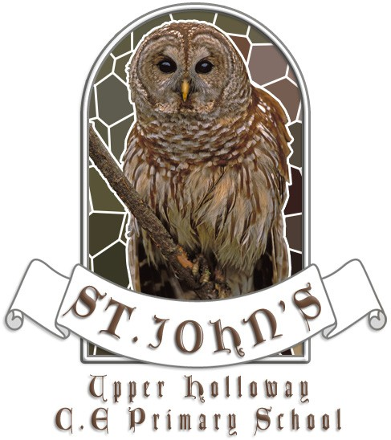

Out of School Clubs

January 2019

Admissions Policy
Places are allocated to children that attend full time education at St. John’s Upper Holloway C of E Primary School.

We aim to provide a safe, clean and welcoming environment for children in our care.
Health & Safety is a high priority in our setting and this includes carrying out regular risk assessment checks and ensuring that there is always a qualified first aider on site.

We aim to allow and cater for children of all abilities to have access to our planned play activities.

Out of School Club Aims:
Our aims are:
- To provide ‘Out of School Care’ in a safe and secure environment for the children of working parents.
- To provide a variety of stimulating and exciting play opportunities for the children in a group situation.

To achieve our aims:
- We will hold club session every day
- We will ensure that there is a qualified first aider on the premises at all times
- We will implement regular fire drills and ensure that all staff and children are aware and familiar with the procedure
- We will encourage the children to be independent, to experiment, to be creative and to develop self-discipline and acceptable behaviour.

Out of School Objectives
The clubs are held within the school setting.

Opening Hours:

Breakfast Club: Monday – Friday 08:00 am – 09:00 am
Buzz Club: Monday – Friday 3:30pm – 6:00pm

How the clubs work
The emphasis is on play and leisure rather than education.

Children have the opportunity to enhance their learning through a wide variety of activities and to promote physical development.

Child Protection
The welfare of children within our care is of utmost importance to our staff, volunteers and management. As such we believe we have a duty to the children, parents/carers and staff to act quickly and responsibly in any instance of abuse that may come to our attention. Positive steps will be taken to develop a trusting relationship with every child and parent/carer.

All staff, volunteers and management who come into contact with the children will be DBS checked. In the staff handbook staff are given specific guidelines relating to avoiding allegations of abuse towards children.

Procedures are in place for dealing with allegations against staff and these will be dealt with directly by Mr Nick Turpin (Deputy Head Teacher).

There will be no less than 2 members of staff on the premises at all times. During warmer weather, if the children are playing outside there will be no less than 2 members of staff in the playground, and at least 1 member of staff in the hall at all times.

Ongoing training will be offered to staff to update child protection knowledge, ensuring they recognise signs and symptoms of possible physical, emotional, sexual abuse or neglect. Any changes to behaviour or physical appearance in a child will be responded to.

Staff are in close contact with the children in our care, therefore staff are in a prime position to notice radical changes in behaviour, or worrying marks or bruises and hear children talking about their experiences may give cause for concern. If staff become concerned about any child, appropriate procedures are taken. Concerns are discussed with senior staff to consider whether the situation should be monitored or immediate action taken.

Signs and symptoms are recorded and dated; this information is strictly confidential. Staff will generally check with parents to see if they have noticed any changes in their child – there may be an easy and appropriate explanation.

Confidentiality will be maintained at all times and staff will continue to support the individual.

Please refer to the main school policy and guidelines for further reference.

Safeguarding

We are committed to safeguarding and promoting the welfare of children and young people and expects all staff to share this commitment.

We have a legal duty to recognise and respond appropriately to:

- Significant changes in the children’s behaviour
- Deterioration in their general well-being
- Unexplained bruising, marks or signs of possible abuse
- Signs of neglect
- Comments children make which give cause for concern

If we recognise one of the above for a child, the severity and circumstance will dictate our actions. The important thing is to do something and not ignore it. We will create an environment to make the children be and feel safe. Any suspicions or allegations of abuse will be taken very seriously, and they will be acted on quickly and correctly.

Four Categories of Abuse – This list is not exhaustive
All Types of abuse can occur in all types of homes, across all social and income groups.

Neglect - Definition
Longstanding and/or severe neglect
Effect on the Childs development
Non-organic failure to thrive

Signs/Symptoms
Constant Hunger, Tiredness, stealing or scrounging
Poor personal hygiene, or inappropriate clothing for weather or activities
Untreated medical problems
Low self-esteem, poor social relations

Physical - Definition
Deliberate injury to the child – allowing injury.
Beyond ‘reasonable’ chastisement
Poisoning, inc. alcohol
Withholding drugs or apparatus
Both the use of an implement e.g. a belt or a physical strike that leave a mark are illegal

Signs/Symptoms
Unexplained or untreated injured, especially if repetitive
Refusal to discuss injuries, and untreated injuries
Shrinking from physical contact
Fear of returning home, undressing, or medical help
Aggression or bullying
Unexplained pattern of absences which may server to hide bruises or other physical injuries

Sexual - Definition
Sexual exploitation of any kind including watching others and viewing pornographic material

Security
The club is committed to provide a safe and secure environment. Staff will adhere to the following guidelines:

- No child will be left unsupervised in the club at any time
- Staff/child ratios of 1:8 children in the Under 8’s will be adhered to and a ratio of 1:10 for older children
- Visitors to the club will not be left unsupervised at any time and adequate identification will be required.
- Children will not be released to anyone other than the recognised parent/carer unless prior notice is given. If staff are unsure of the person collecting the child that child will remain at the club and parents will be informed of the decision
- Entrance to the club will be monitored to ensure security at all times. Children will be signed in and out of the club
- Permission for the use of videos and photography will have been sought from parents/carers at the time of completing the school application. The club will work under these guidelines

Emergency Fire Procedure Policy
Upon hearing the fire alarm all staff and children should follow carefully the instructions below:

- Escort children to the top playground and take register
- Check all toilets

Staff
- Escort all the children calmly, quietly and safely outside onto the top playground
- Line them all up along the playground away from the school building
- Elected member of staff to check toilets before going onto the playground
- Whilst on the playground keep the children quiet and still while the register is taken
- Await instructions before leaving the playground and returning to the hall

Toileting
All children must ask a member of staff if they need to go to the toilet, so all staff know who has gone if there is a fire. Nursery/Reception children are accompanied to the toilet by an older child (buddy system).

All children are encouraged to wash their hands before and after snacks.

Use of mobile phones and cameras
Photographs will only be taken of children with their parents’ permission. Only the club camera will be used to take photographs of children at the Club, except with the express permission of the manager. Please see our mobile and camera policy for full information.

Toilet Supervision
Under 8’s – Children will be escorted to the toilets and staff will remain outside the door to assist if help is requested.
Over 8’s – All children will ask to use the toilet facilities. Staff will monitor numbers and ensure children return to their play in the appropriate location

Related Policies and Information
Safeguarding & Child Protection Policy December 2018
Safer Recruitment
Uncollected Child Policy

Buzz Club Safeguarding Lead is Nikki Plaw
Breakfast Club Safeguarding Lead is Nick Turpin

