Dear parents and carers,

Welcome back to a new school year. I hope you all had a wonderful holiday and are feeling refreshed!

**Key Dates:**

**Class Assembly Friday 23rd February 9:30AM**

**Easter service Wednesday 27th March at 10.00 AM**

**Parents evenings Monday 25th and Tuesday 26th March**

**Reminders:**

* **PE:** Our PE day this term is **Friday** (Coach Johnny).
* Please wear your PE kit on **Friday**. The correct kit is a navy T-Shirt, blue shorts or jogging bottoms and trainers for outdoor PE, or black plimsolls for indoor lessons.
* **Homework:** Homework is set on Fridays and collected in the following Wednesday. Homework is set online using Times Table Rock Stars and Spelling Shed.
* Please make sure your child reads for at least **10 minutes per day** and records something in their yellow Reading Record. For those on chapter books, it is still important that they have the opportunity to read to an adult and discuss the book. Please ensure the sentence stems at the back of the reading record are used to write the comment.
* **Reading records are checked daily and need to be in school every day**. They are also used to communicate with parents, so please do check for notes (and of course, feel free to respond).
* Links to support learning can be found on the Year 4 page of our school website: [www.stjohnuspperholloway.co.uk](http://www.stjohnuspperholloway.co.uk).

If you would like to meet me to discuss anything, please feel free to make an appointment for after school.

***Miss Banu, Year 4 Class Teacher***

**St John’s Upper Holloway CE Primary School**

‘Love each other as I have loved you’ – John 15:12

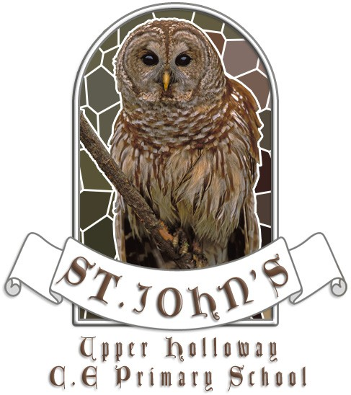

**Year 4**

**Spring term curriculum letter**

Our science topic this term is

The digestive system, teeth and food chains: what helps us to digest our food properly?

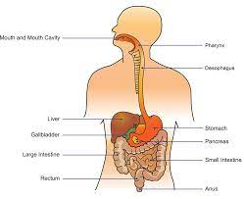

Our humanities topic this term is

The achievements of the earliest civilisation: Shang Dynasty. What was life like during the Shang Dynasty?

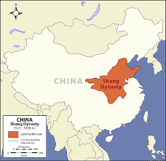

**Literacy**

This term we will focus our learning around the key texts: ‘Leon and the Place Between’; ‘The Village that Vanished’ and ‘Varjak Paw’. We will be exploring the stories and using them to inspire our writing. We will write various pieces including: written predictions, setting descriptions, recounts, character descriptions, a parallel narrative, information writing – fact files, persuasive writing – speeches, diary writing, continuation of the ending and recounts. In reading we will continue to develop key comprehension skills. Children will continue to develop their spelling, punctuation and grammar skills, learning about a range of literacy forms.

Fronted adverbials

Apostrophes to mark plural possession Pronouns for cohesion and repetition

Pronouns for cohesion and repetition

**RE**

In this unit we will be learning to answer questions such as:

How does a Hindu priest help Hindus worship at the mandir?

Why do Hindus go on pilgrimage?

How do Hindus worship at home?

Why is the Aum symbol important to Hindus?

Why do Hindus have many images of God?

**PE**

This term the children be learning about dance and telling a story through movement with Coach Johnny.

**Music**

In this unit, we will explore anti-bullying through rap and grime. The main song which will be our focus is called ‘Stop!’. We will bring in our PSHE learning to help us understand the importance of stopping bullying and how bullying can affect the lives of those involved.

**PSHE**

In this unit we will be learning about: commonly used drugs that are not medicines, how those drugs affect the body and the behaviours they cause. We will also revise how asthma is treated and what to do if someone is having an asthma attack.

**Spring Challenge!**

If you’re feeling creative, why not have a go at creating a Shang artefact at home? You could model, draw, paint, collage, use a computer or anything else you can think of to make an object you would find on a Shang Dynasty archaeological site. If you’d like to have a go, you can then bring in your creation to present to the class on the last day of term.

**Computing**

This term children will be learning about data logging, along with practising e-safety.

**Maths**

This term our main focuses will be multiplication and division, fractions and measurement - specifically area. For these three topics children will be relying hugely on their ability to fluently recall their timetables. Fluent recall of times table facts will lighten cognitive load when working through a method, enabling them to fully process and understand new concepts.

**Humanities**

This term we will be learning about one of the first ancient civilisations - the Shang Dynasty. We will also be learning in more depth about plate tectonics, and discovering the world’s major biomes.

**Spanish**

In this unit, we will learn the words for family members in Spanish and how to explain what relation they are to us, how old they are and what they are called. We will also learn to understand numbers 1-100, count and use them in sequence.

**Art and DT**

This term we will be exploring sculpture linked to our humanities topic: The Shang Dynasty. We will experience surface patterns and textures, discuss own work and work of other sculptors and analyse and interpret natural and manmade forms of construction.

**Science**

In this unit we are learning about the human digestive system and how it breaks down food to provide us with nutrients and energy. We will also be exploring different types of teeth, what their role is and how we can look after them. Finally, we will be learning that animals have skeletons and muscles for support, protection and movement. We will be working scientifically by using secondary sources to research all about teeth and digestion. We will also be grouping and classifying teeth and using different ways to report on findings and draw conclusions.

.

**Year 4 Curriculum letter**

**Spring term 2024**